Call for Extraordinary General Assembly
on 14 November 2015 in connection to IFLRY’s Executive Committee from 13-15 November 2015 in Santo Domingo, the Dominican Republic

The IFLRY Bureau would like to propose membership disaffiliations and suspensions in accordance with its wish to get all IFLRY members into good standing. However, as it is an exclusive right for the General Assembly to deal with membership expulsions (Article XVII of the IFLRY Rules of Procedure), the IFLRY Bureau needs to call an extraordinary General Assembly to deal with this exact point only during IFLRY’s coming Executive Committee taking place from 13-15 November 2015 in Santo Domingo, the Dominican Republic.

In accordance with Article XII of the IFLRY’s Statutes, the IFLRY Bureau would therefore call upon an Extraordinary General Assembly to take place on 14 November 2015 to deal with this point only.

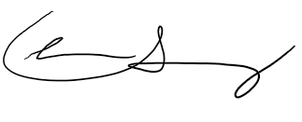
On behalf of the IFLRY Bureau

, 15 October 2015

Christian Scharling
IFLRY President

